**Top 12 things to do in Ithaca**

These aren’t in any specific order, but these are the twelve things I most highly recommend to do in Ithaca.

1. Allan H. Treman State Marine Park. The walking trail that goes from Allan Treman Park to Cass Park is a nice flat walking trail.

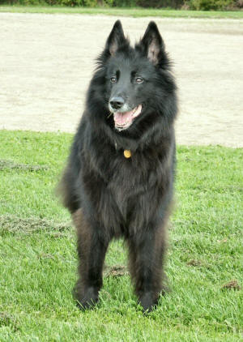 The reason I included this picture is that there is also a dog park at Allan Treman. Near the Park is a place called the Hangar Theater that has local theater students and people of the community put on excellent plays.

1. Ithaca Farmers market is open Saturdays and Sundays. They have wine, cheese, food, crafts, and music. Plan on eating lunch. [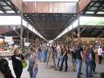](http://images.google.com/imgres?imgurl=http://farm4.static.flickr.com/3223/2856516894_31d39cce37.jpg&imgrefurl=http://www.flickr.com/photos/boojee/2856516894/&usg=__h3YqKlS_7kKTnl6kMdJyiei2Hc0=&h=375&w=500&sz=170&hl=en&start=1&um=1&tbnid=DaFyeo8lgO9xEM:&tbnh=98&tbnw=130&prev=/images?q=ithaca's+farmers+market&hl=en&sa=N&um=1)
2. Fall creek pictures are owned by the same people who own #8 (Cinnemopolis) it’s a small town theater different from any movie theater in large cities. They have herbal tea, brownies and popcorn with parmesan cheese.
3. Clinton house and Kitchen Theater is a great place to buy tickets for local theater.

[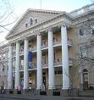](http://images.google.com/imgres?imgurl=http://wpcontent.answers.com/wikipedia/commons/thumb/f/f4/ClintonHouseInIthacaNY.jpg/300px-ClintonHouseInIthacaNY.jpg&imgrefurl=http://www.answers.com/topic/ithaca-new-york&usg=__hcx-v64OAFehT6dRDAUeCPgsDHQ=&h=319&w=300&sz=31&hl=en&start=1&um=1&tbnid=NgTXf_F5eKNpoM:&tbnh=118&tbnw=111&prev=/images?q=ithaca+clinton+house+kitchen+theater&hl=en&um=1)

1. Northside wine and spirits is my favorite place to buy wine or special order any kind of beverages. Their staff is very knowledgeable.

[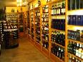](http://images.google.com/imgres?imgurl=http://northsideliquorstore.com/wordpress/wp-content/uploads/2009/04/northside-liquor-store007.jpg&imgrefurl=http://northsideliquorstore.com/&usg=__K1l6pWbl9Z5ER--Mfmd3VzrZgp8=&h=225&w=300&sz=28&hl=en&start=8&um=1&tbnid=2Z3cIHjGohLeaM:&tbnh=87&tbnw=116&prev=/images?q=northside+wine+and+spirits&hl=en&um=1)

1. The South Hill Recreation Way trail you can park right on Hudson Street or Hillview and the first ¾ of a mile is very flat and from there on is somewhat hilly. It’s a great place I probably go about once a week.
2. Dewitt mall is a unique mall that used to be a school and has several great restaurants.

[](http://images.google.com/imgres?imgurl=http://www.pastimes.com/photos/mall3.png&imgrefurl=http://www.pastimes.com/history.php&usg=__9VPHlFHTW_UCqDlUMjYID3O3hsE=&h=207&w=313&sz=107&hl=en&start=8&um=1&tbnid=SlKfejkyIwPOGM:&tbnh=77&tbnw=117&prev=/images?q=ithaca+dewitt+mall&hl=en&sa=X&um=1)

1. Cinnemapolis is off the Ithaca commons. It’s a fun theater.
2. Cornell plantations is a great place for a walk or picnic. There are lots of specimen trees. Good to combine with a trip to number 10-

[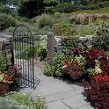](http://images.google.com/imgres?imgurl=http://www.anyheart.org/cornell/images/c-01.jpg&imgrefurl=http://www.anyheart.org/cornell/index.html&usg=__Dtc6UruLPjs0LGFZ2OxT3MMfa7Y=&h=400&w=400&sz=120&hl=en&start=6&um=1&tbnid=zcAbxWsPTX7xdM:&tbnh=124&tbnw=124&prev=/images?q=cornell+plantations&hl=en&um=1)

1. Beebe Lake which is a nice spot to see. Hard to find parking. But there are very cool buildings down in the gorge.

[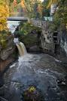](http://images.google.com/imgres?imgurl=http://sawthelightphotography.com/images/Below-Beebe-Lake.jpg&imgrefurl=http://sawthelightphotography.com/page1.aspx&usg=__cjuTUl_Q4TrOEc8qnr7i1k5_p_k=&h=576&w=384&sz=52&hl=en&start=6&um=1&tbnid=CF5iQRAN6ySQNM:&tbnh=134&tbnw=89&prev=/images?q=ithaca+beebe+lake&hl=en&um=1)

1. Stevens suspension bridge is very fun to walk across it has great views and easy nearby parking.

[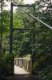](http://images.google.com/imgres?imgurl=http://www.bridgemeister.com/thumbs/ponystevens-thumb.jpg&imgrefurl=http://www.bridgemeister.com/list.php?type=state&state=New+York&usg=__I2EOuRAASey0FmTKmweX3BjqjOg=&h=171&w=111&sz=5&hl=en&start=5&um=1&tbnid=VIcaby6LflAfMM:&tbnh=100&tbnw=65&prev=/images?q=ithaca+stevens+suspension+bridge&hl=en&um=1)

1. Cascadilla park road is Ithaca’s Lombard Street of Ithaca right next to it at the bottom is a great small park and hiking uphill to Cornell. All uphill but a great beautiful hike.

[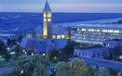](http://images.google.com/imgres?imgurl=http://scienceblogs.com/framing-science/upload/2007/04/Cornell.jpg&imgrefurl=http://scienceblogs.com/framing-science/2007/04/talk_on_framing_science_at_cor.php&usg=__DYYJHzOox4YqbYrvdWp8e-KIzeo=&h=320&w=510&sz=98&hl=en&start=1&um=1&tbnid=prleVPW6uq-2-M:&tbnh=82&tbnw=131&prev=/images?q=cornell&hl=en&um=1)